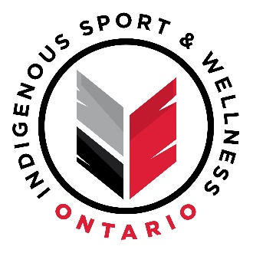
Indigenous Sport & Wellness Ontario - Updated Statement on COVID-19
Toronto, ON – January 16, 2020 — ISWO continues to monitor the COVID-19 pandemic situation in the province of Ontario and bases its decisions on the recommendations provided by public health authorities. Given the rise in the number of COVID-19 cases and a return to stay at home measures for many areas of the province (including a move to online school for many students), ISWO extended its in-person program closures until February 28, 2021. The organization will reassess the situation in March and provide an update as to the potential for resuming in-person program opportunities at that time. In the meantime, ISWO is committed to providing a variety of online programs and community-based grant opportunities, to continue to support the wellness of Indigenous youth and communities across Ontario.
In recent weeks, the number of new cases is dramatically on the rise and the risk of COVID-19 is particularly higher for Indigenous communities, who may be more vulnerable and not have the resources available to deal with an outbreak. While we understand that this decision may be disappointing, the safety and wellbeing of the youth and communities we serve, and our staff who deliver programming, is paramount. ISWO looks forward to delivering in-person programming for Indigenous youth, families and communities in Ontario, when it is safe to do so.
The situation regarding COVID-19 continues to evolve and we would encourage all members of the public to access the following verified Public Health websites for the most up-to-date and accurate information, or alternatively, to check-in with your local public health authority:
- Ontario Public Health
- Canada Public Health
- Centre for Disease Control and Prevention (CDC)
These verified public health websites provide information on how to practice measures to keep yourself and your family members safe and as well, what to do in case you develop symptoms. We encourage you to get tested if you think you may have been exposed or are experiencing symptoms. For more information about COVID-19 testing, please visit: https://covid-19.ontario.ca/self-assessment/.
For the most up-to-date information regarding the status of upcoming online/virtual ISWO events, we recommend following us on social media, visiting our website, or subscribing to our newsletter and e-blasts.
Stay safe, stay positive and look out for those who may be more vulnerable during this time.
Sincerely,
Marc Laliberte
President, Indigenous Sport & Wellness Ontario

